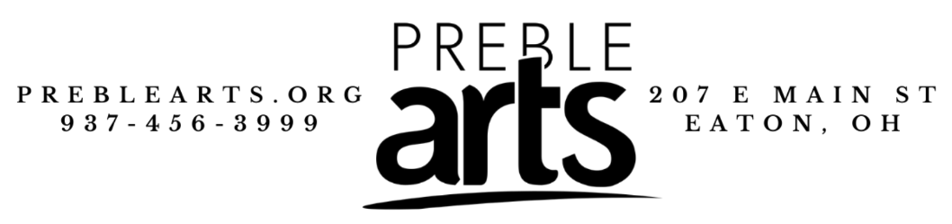
Policy Handbook
- Studios and Labs
If any individual damages supplies or any other equipment from any of the studios, classrooms, or labs, Preble Arts is permitted to fine the individual for the damages made.
- Demonstrating Respect
For any class or event, all participants are expected to act in an appropriate and respectable way. If in any way, a participant is found to be acting in a way that is deemed inappropriate or disrespectful to Preble Arts, Preble Arts’ property, other students, employees, or any other person or item that may cause disruption or damage, Preble Arts has the right to remove the student(s) from the class/event they are enrolled in.
- Breaking the Service Agreement
If any individual is found to break the Service Agreement, Preble Arts has the right to remove the student(s) from the class/event they are enrolled in. If a student has been removed from a class/event due to breaking the Service Agreement, they are not considered eligible for a refund, partial or full.
- Dress Code
For any class or event, it is expected that all attendees dress in a manner that is appropriate and safe for the class they will be attending. If any participant is dressed in a way that makes the other attendees uncomfortable, or in a way that is not safe for the project they will be creating, Preble Arts has the right to ask them to change or to leave. If an attendee is asked to leave, they will not be considered eligible for a refund, partial or full.
- Inclement Weather
If a class is scheduled on a day where Preble Arts is unable to open due to inclement weather, the class will be either rescheduled or canceled. If you are unable to attend the rescheduled date, you may be eligible for a credit or a full refund. You may receive either a phone call or an email to inform you of this change.
- Transportation
All attendees are expected to find their own way of transportation to any event or class held at Preble Arts. If an attendee is unable to find transportation (and they do not let Preble Arts know within 72 hours of the event), they will not be eligible for a refund or credit.
- Medical Emergencies and Information
If any attendee has any sort of health problems that are relevant to the class/event or may be something the staff on site should know about, it is the participant’s responsibility to inform staff. If the participant is in need of any sort of special treatment due to their health, it is their responsibility to let Preble Arts’ staff know at the time of registration (at least 72 hours before the day of the event).
If a participant needs medication, they are allowed to bring their medication to any event, however, they must inform Preble Arts’ staff beforehand. No sharing of medication is allowed in any manner, and any participant that is caught attempting to share medication with anyone may be asked to leave. If asked to leave, the attendee will not be eligible for a refund or credit.

207 East Main St., Eaton, OH 45320
(937)-456-3999
www.preblearts.org
info@preblearts.org

