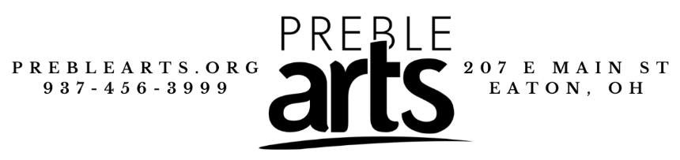
Preble Arts Service Agreement
This agreement is between you and Preble Arts. Your participation is subject to the terms and conditions in this agreement. If you do not agree to these terms, you may not attend the event. This form is not relevant to art parties and other venue rentals.
For contract information regarding art parties and other venue rentals, please directly contact Preble Arts.
- What’s Included
The agreed upon class, workshop, event, etc. that you have registered for and paid for. This will include supplies listed in the class description, instruction listed, and other listed inclusions.
- Cancelations
When canceling your registration, you must notify Preble Arts at least 3 days before the scheduled date of the event. If you do not notify Preble Arts in this timeframe, you will not qualify for a possible refund or credit.
If Preble Arts needs to cancel the event, you will be notified as soon as possible. Refunds/credits will be issued if applicable, or the event will be rescheduled.
By registering and paying for a class, you are agreeing that you will attend the event you registered for. If, for any reason, you do not notify Preble Arts that you are unable to attend the event, you will not qualify for a possible refund or credit.
- Refunds
If you are unable to attend a class or event, and are eligible for a refund, a refund fee of 2.7% will be subtracted from the total refund amount. In special cases, this refund fee may be waived by Preble Arts.
All refunds must be requested no later than 72 hours before of the event to be eligible. You are not eligible for a refund if you have attended the class or event, either fully or partially.
- Photography and Advertising
By registering for an event at Preble Arts, you are consenting to have pictures taken of the registrant(s) and possibly have those pictures used on flyers, the Preble Arts website, or other platforms for advertising purposes.
- Rescheduling
If Preble Arts or a class instructor, for any reason, can no longer host the event on the originally scheduled date and need to reschedule, all registrants will be contacted and notified of this change. If for any reason, the registrant can no longer attend the event due to this change, the registrant may be asked to attend the event on a separate day to allow them to attend the event as planned. If the registrant can not attend on any other day, there is a possibility that they may qualify for a refund or credit.
- Safety
By registering for an event, you agree that the registrant(s) will abide by all safety guidelines, including those set by the instructor and the PCAA staff. The registrant(s) agree to keep Preble Arts in clean and working order by cleaning up after themselves and reporting any damaged, dirty, missing equipment, tools, or supplies.
- Waitlist and Spot Reservation
If an event registration is full, you may join the waitlist. By joining the waitlist, you are not registering for the event but are instead signing up to be notified of a spot opening.
If you can not attend the first day of class and do not notify Preble Arts, you give Preble Arts permission to cancel your registration and replace your spot in the event.
- Liability
By registering for an event and in consideration for the Preble County Arts Association (PCAA) making programs available to the registrant(s), you hereby release the PCAA, its employees, volunteers, instructors, and agents from any and all liability, cost/expense associated with any injury the registrant(s) may sustain while participating in any of the programs and activities. Furthermore, you hereby hold the PCAA; its employees, volunteers, instructors, and agents harmless for any damage, loss, or claims to the registrant(s) person or property. You assume full and all risks and responsibilities on the premises, both known and unknown. By registering, you agree that the registrant(s) understand that payment must be made in full and there will be no refunds of money, either full, or partial after the first day of camp/class.
- Demonstrating Respect
By registering for a class or event, you and all participants agree to act in an appropriate and respectable way. If in any way, a participant is found to be acting in a way that is deemed inappropriate or disrespectful to Preble Arts, Preble Arts’ property, other students, employees, or any other person or item that may cause disruption or damage, Preble Arts has the right to remove you and any other participants from the class/event you are enrolled in.
- Dress Code
By registering for a class or event, you agree to dress in an appropriate and safe manner. To be considered appropriate, you must be fully clothed, including socks and shoes. To dress in a safe manner, you must not be wearing anything that will get in the way of the class you will be taking or the project you will be creating. Your outfit must not cause risk of injury, or endanger yourself, Preble Arts’ staff, instructors, other students, or any other person or item.
By registering for a class or event, you understand that if you break the dress code, you may be asked to leave, and you will not be eligible for any refund or credit.
- Gallery and Payment Schedule
For any individual that sells artwork in our gallery, Preble Arts will receive a 30% commission on any item sold.
Payments for instructors and gallery artists are issued once a month.
- Hours of Operation
Preble Arts’ normal business hours are:
Tuesdays-Fridays: 11:00 AM – 6:00 PM
Saturdays: 10:00 AM – 2:00 PM
Sundays-Mondays: Closed

At any time, this schedule may change due to local events or weather. If this schedule does change, you will be notified (if you are registered for a class or event), and a post may be made on Preble Arts’ social media.
- Additional Forms
For special classes, such as Summer Camps, music lessons, etc., you may be asked to sign a form to further clarify your consent to the topics addressed in this document.
If you do not agree with the topics in this document, you will not be permitted to register for any class or event.
- Studios and Labs
By registering for a class or event, you agree not to damage any supplies, equipment, etc. If you do damage anything, you will be fined for the damages.
Thank you for taking the time to review our Service Agreement. If you have any questions, please contact us via phone at (937)-456-3999, or via email at info@preblearts.org.

207 East Main St., Eaton, OH 45320
(937)-456-3999
www.preblearts.org
info@preblearts.org

